Checklist for Required Services Reports

School Name______________________________

School Year of Submission___________________

FILENAME:
CompleteSchoolName. SiteCode. 20xx-20xx. ReqSrvs. Filename

_____ Required Services Reimbursement Summary, SY 20xx-20xx – PDF
_____ Required Services Reimbursement Form and Summary, SY 20xx-20xx – Excel
_____ Required Services Summary Time Record Forms [for each employee (signed)] – PDF
_____ All required signatures
_____ Cover letter to Dr. Cade Brumley, State Superintendent of Education- PDF

Signature of Principal: __________________________________

Letter Example
[DATE]

Dr. Cade Brumley, State Superintendent
Louisiana Department of Education
PO Box 94064
Baton Rouge, LA 70804-9064
Dear Dr. Brumley:

In accordance with paragraph (c) of section 7 of the regulations of the State Board of Elementary and Secondary Education pursuant to the Louisiana revised Statutes 17:361- 17:365, I hereby authorize Sr. Carol Shively, OSU, Superintendent of Catholic Schools, Diocese of Shreveport, to receive on behalf of this school the reimbursement to which the school is entitled and for which the appropriate claim form is attached.

Sincerely,
Signature
Principal

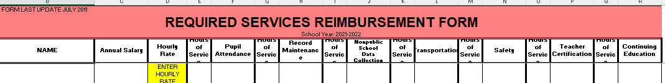
Form and Summary EXCEL

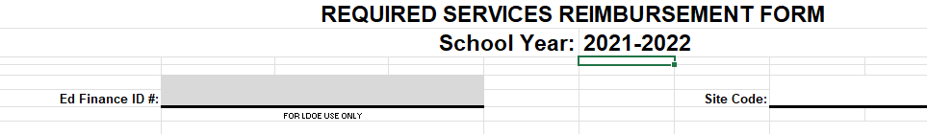

Summary Time Record PDF

