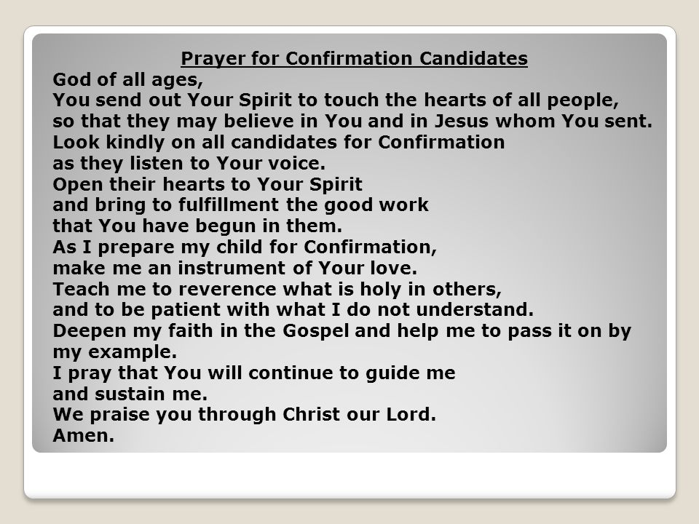
Lord, Send out your spirit and touch the hearts of these young people preparing for the Sacrament of Confirmation. We ask the Holy Spirit to look kindly upon these young people as they listen to your voice.
Open their hearts to the Holy Spirit and bring them to the fullfillment of the good work you have begun in them.
Lord, we offer prayers for the parents of these students make them an instrument of your Love, deepen their in the Gospel and help them to pass it on by example.
Lord, continue to guide and sustain these students and parents as they move forward on this journey of faith. We praise you through Christ our Lord. Amen

- Prayer to the Holy Spirit
Come, Holy Spirit, fill the hearts of your faithful.
And kindle in them the fire of your love.
Send forth your Spirit and they shall be created.
And you will renew the face of the earth.
Lord,
by the light of the Holy Spirit
you have taught the hearts of your faithful.
In the same Spirit
help us to relish what is right
and always rejoice in your consolation.
We ask this through Christ our Lord.
Amen.

O Lord Jesus Christ, Who before ascending into heaven, promised to send the Holy Ghost to finish Your work in the souls of Your Apostles and Disciples, deign to grant the same Holy Spirit to me, that He may perfect in my soul the work of Your grace and Your love.
Grant me:
· the Spirit of WISDOM,
that I may despise the perishable things of this world, and aspire only after the things that are eternal;
· the Spirit of UNDERSTANDING,
to enlighten my mind with the light of Your divine truth;
· the Spirit of COUNSEL,
that I may ever choose the surest ways of pleasing God and gaining heaven;
· the Spirit of FORTITUDE,
that I may bear my cross with You, and that I may overcome with courage all the obstacles that oppose my salvation;
· the Spirit of KNOWLEDGE,
that I may know God and know myself and grow perfect in the science of the Saints;
· the Spirit of PIETY,
that I may find the service of God sweet and amiable; and
· the Spirit of FEAR,
that I may be filled with a loving reverence towards God and may dread in any way to displease Him.
Mark me, dear Lord, with the sign of Your true disciples, and animate me in all things with Your spirit. – Amen –
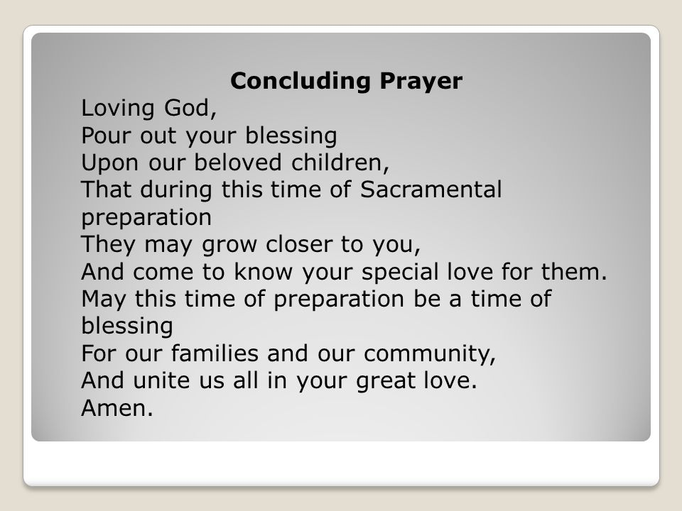

Loving God, Bless these your beloved sons and daughters during this time of preparation for the Sacrament of Confirmation. Draw them closer to you, as they come to know your special love for each of them. May this time of Preparation be a time of blessing for our families. Unite us all in your great love. Amen.

