**Checklist for Required Services Reports**

School Name______________________________

School Year of Submission___________________

**FILENAME:   
CompleteSchoolName. SiteCode. 20xx-20xx. ReqSrvs. Filename**

_____ Required Services Reimbursement Summary, SY 20xx-20xx – PDF

_____ Required Services Reimbursement Form and Summary, SY 20xx-20xx – Excel

_____ Required Services Summary Time Record Forms [for each employee (signed)] – PDF

_____ All required signatures

_____ Cover letter to Dr. Cade Brumley, State Superintendent of Education- PDF

**Signature of Principal:** __________________________________

**Letter Example**

[DATE]

Dr. Cade Brumley, State Superintendent

Louisiana Department of Education

PO Box 94064

Baton Rouge, LA 70804-9064

Dear Dr. Brumley:

In accordance with paragraph (c) of section 7 of the regulations of the State Board of Elementary and Secondary Education pursuant to the Louisiana revised Statutes 17:361- 17:365, I hereby authorize Sr. Carol Shively, OSU, Superintendent of Catholic Schools, Diocese of Shreveport, to receive on behalf of this school the reimbursement to which the school is entitled and for which the appropriate claim form is attached.

Sincerely,

*Signature*

Principal

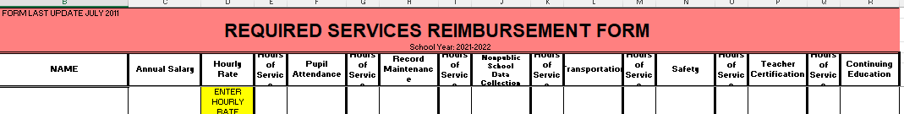**Form and Summary EXCEL**

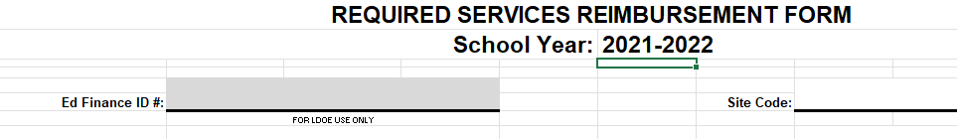

**Summary Time Record PDF**

